Portrait of a Countess
Prepared by Théo Armour
theoa@msn.com
+1 415 381 1888

28 June 1999

Preface
This paper sets down what I know and what I have learned regarding a painting in our possession that, in various appraisals, is referred to as the “Portrait of a Countess”.

I hope to update this paper from time to time as I learn more about the painting and provenance.

The intentions are threefold:
- To establish recognition for the painting as a historical resource
- To establish its monetary worth
- To establish a starting point for genealogical research for the Russian element of our family

Introduction
I, Theo Armour, whose legal name is Norman Armour III, inherited a painting in 1990 from my grandparents, Norman Armour and Myra Koudachev Armour. Here is a photograph of the portrait:

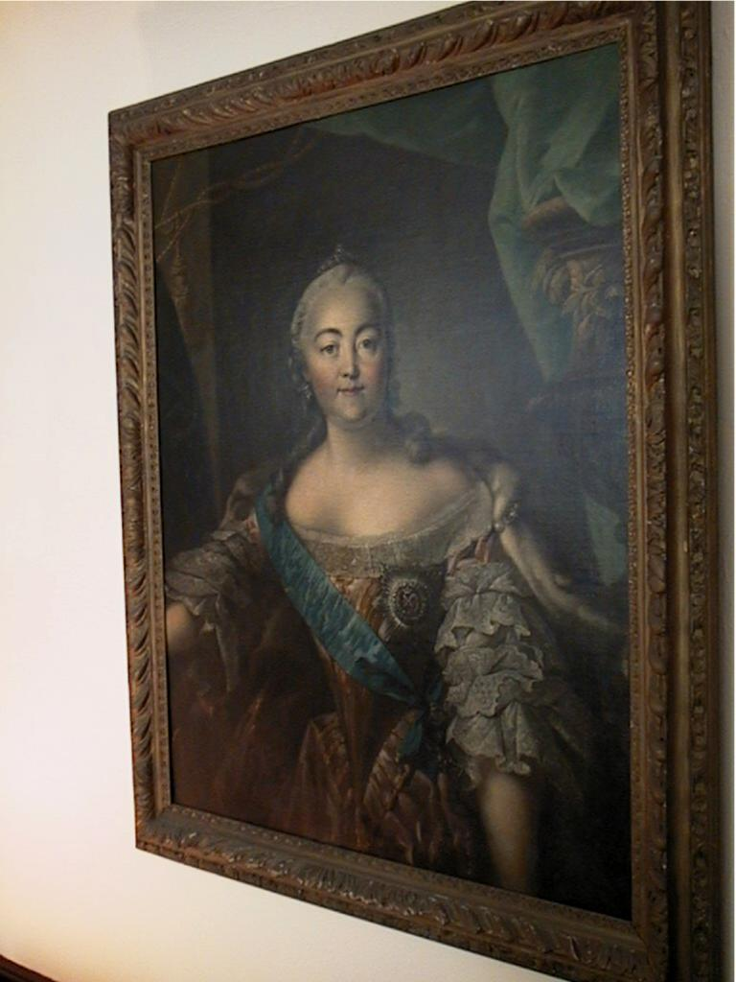
“Portrait of a Countess”

I apologize for the fact that the view is not straight on, but there is too much glare in a straight on view.

My grandparents always displayed this portrait in the living room, most recently at 825 Fifth Avenue in New York City. They and my parents always referred to the portrait as the portrait of Catherine the Great.

I have, however, no concrete evidence that this portrait is truly a portrait of Catherine the Great. This paper is an attempt to establish the provenance of the “Portrait of a Countess”.

How did this painting come to be in our possession?
Soon after graduating from Harvard Law School in 1915, Norman Armour joined the Foreign Service. His first post was as Third Secretary in the American Embassy in St Petersburg. He was a witness to many of the significant events in the Russian Revolution. In one of the rare happy moments of that period he was more than a witness. He met and fell in love with a young Russian aristocrat, the Princess Myra Koudachev. The Koudachevs were a aristocratic family (http://www.chivalricorders.org/nobility/gotha.htm ) descended from Tartar princes (http://www.geocities.com/Athens/Olympus/6278/atoztitles/mongolian.htm ).

Myra Koudachev’s maternal grandfather was Aleksandr Fyodorovich Trepov, (born 1862 - died 1928). He was Prime Minister of Russia from 24 Nov 1916 to 9 Jan 1917. We were told, in our family, that, in the course of a long government career, he was for a while in charge of the collection of works of art in the Hermitage in St Petersburg and that he was responsible for obtaining the very significant collection of French Impressionists now in that Museum.

During the course of the Revolution, the Koudachevs, and Trepov left Russia. One item they brought with them to Stockholm, and later to Paris, and then to the United States was the “Portrait of the Countess”.

Is this a portrait of Catherine the Great?
The September 1998 issue of the National Geographic magazine includes an article written by Erla Zwingle with photographs by Sisse Brimberg on Catherine the Great.

The article shows three portraits of Catherine. In two of the portraits, Catherine is wearing a medal - the insignia of the Order of St. Catherine. The Order was instituted by Peter the Great in 1714 in honor of his wife, and was the highest Russian honor awarded exclusively to women -- only 12 women outside the royal family could be members of the Order at a time.

Here are scans of the three portraits of Catherine as shown in the National Geographic magazine.

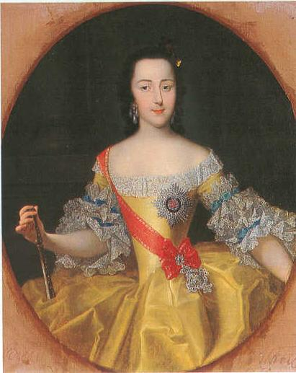
Georg Christoph Grooth, State Hermitage Museum, St Petersburg

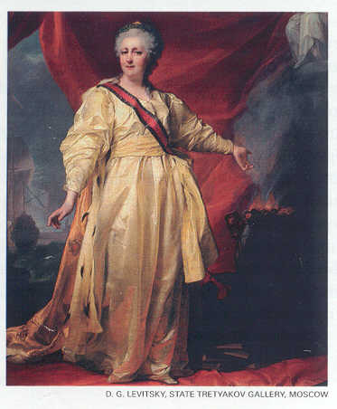
D G Levistsky, State Tretyakov Gallery, Moscow (without insignia)

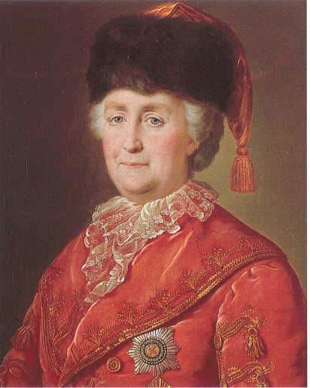
Mikhail Shibanov, State Hermitage Museum, St Petersburg

Below is a detail of the Portrait of a Countess, showing a close up view of the insignia.
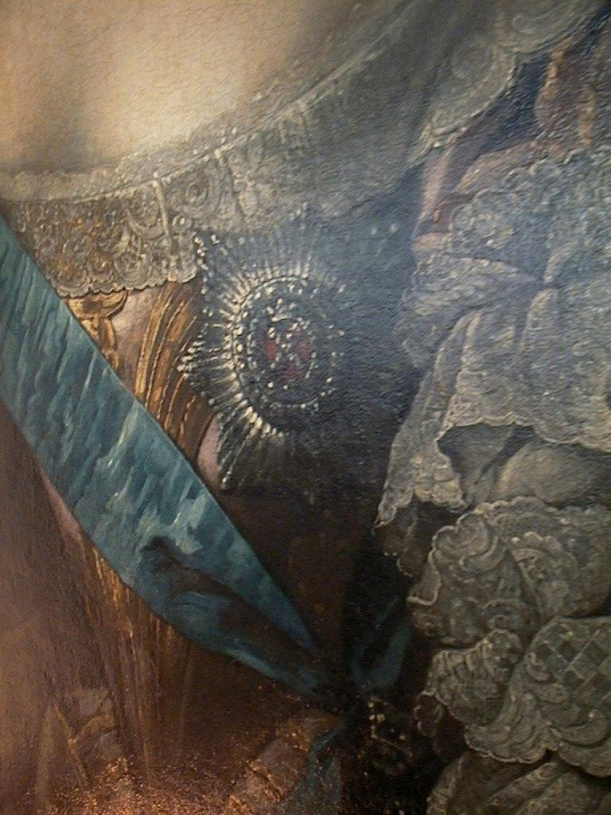

The display of the insignia in itself does not prove that the portrait is of Catherine. The portrait could be of any of the recipients of the medal.

The insignia shown in the “Portrait of a Countess” is virtually identical to the insignia shown in two of the portraits in the article in the National Geographic magazine.

It is worth noting that the style of the insignia changed over time. Below is a photograph of the insignia that was probably made at the beginning of this century as shown in an article in the Wall Street Journal on 11 June 1999. Notice the crown is in the center and that there is no cross.

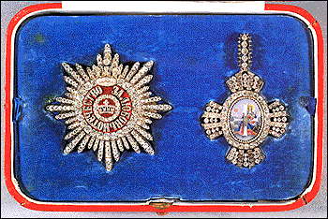
Insignia of the Order of St. Catherine

Furthermore, there are a number of similarities in the facial features in the four portraits
- High forehead
- Round eyes
- Long thin straight nose
- Small mouth with pursed lips
- Strong chin

Other portraits of Catherine the Great
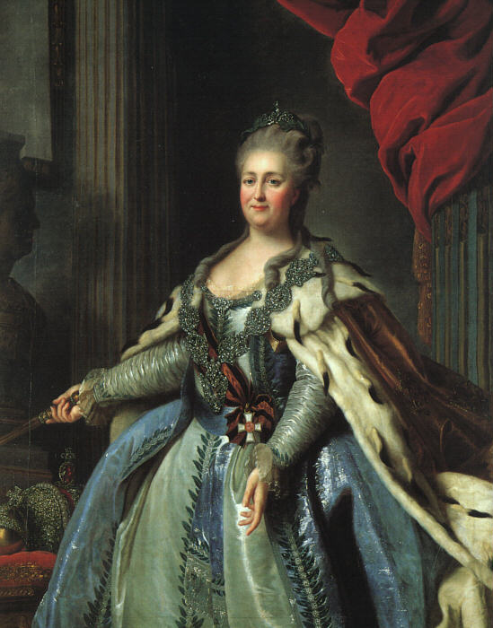
Artist and location unknown, captured from: http://www.sangha.net/messengers/Catherine.htm#links

Further Actions
I am looking for people to contact regarding opinions as to the identity of the individual in “Portrait of a Countess”

Two possibilities come from the National Geographic magazine:

Sergei Letin, art historian at the State Hermitage Museum, St Petersburg
Sisse Brimberg, photographer for the National Geographic magazine

Another possibility is to send an email to:
interface@hermitage.ru

I would appreciate any further suggestions as contacts who might be willing to render an opinion as to the identity of the individual depicted in the portrait as well identifying the artist of the portrait.

I would also appreciate any advice as how best to establish the provenance of such items.

